ETX-1P

Final Test Instructions

Last Updated: 14/01/2024

Contents

1 Required Test Equipment 3

2 Preparations for Testing 4

2.1 U-boot download 4

3 Visual Inspection 7

4 Basic Operational Tests (BOT) 1

4.1 Automated BOT 1

4.2 Manual BOT 1

5 Environmental Stress Screening (ESS) 11

6 Automated Final Tests 11

6.1 Setup 11

6.2 Running the Test 11

7 Manual Final Tests 11

7.1 General Function Tests 11

7.2 Identification Test 12

7.3 Test FD Button check 14

7.4 Cellular Modem Test (according to option) 15

7.5 GPS Test (according to option) 24

7.6 Wi-Fi Test (according to option) 24

* 1. Data Test 30

## 7.8 Test SSH connection ETH port 4 or 6 test (according to option)………………………………………………………30

8 Preparations for Shipment 32

9 Factory Setting 32

10 Safety Test 33

Appendix A. EEPROM Parameters 34

Appendix B. ETX-204 generator configuration 36

# Required Test Equipment

|  |  |  |  |
| --- | --- | --- | --- |
| Item | Generic Name/Description | Manufacturer | Model |
|  | ETX-1P - UUT | RAD |  |
|  | SFP for GE | RAD | SFP-9G |
|  | RJ45/DB9 Terminal and Serial cables | RAD | CBL-RJ45/D9/F/6FT x 2 |
|  | GETH Cable | N/A | N/A |
|  | Terminal S/W | N/A | Procomm |
|  | TFTP - S/W | N/A | N/A |
|  | GE/FE Generator | RAD | ETX-204AX x2 |
|  | Serial port LOOP cable | RAD | CBL-RS232-RJ45-RJ45 |
|  | GPS Passive antenna | RAD | T-RPA-PB0-393353-1M-X-005 |

# Preparations for Testing

## U-boot download

## 

1. The process of loading u-boot software and UUT option (according to latest version in ECO) is performed by PC Linux only.
2. Block diagram below (Figure 1) depicts connection of ETX-1P to terminal

through serial port and connection of TFTP server to device Ethernet lan1

## 

**

Figure 1 : ETX-1P Terminal and Ethernet port connection

1. Connect terminal to Serial Port 2 (upper connector) and relocate jumper J21 as shown in figure below:



1. Transfer UART image to the ETX-1P, set jumpers J18, J19, J20 should be installed for “UART Mode” and relocated as show in figure below:



4. Use following command:

***cd /home/etx-1p/projects/boot/u-boot***

***sudo ./deploy.sh 2*** (2 is the serial number (USB port)

Waiting for the process to complete until the command:

PCPE>>

PCPE>>***setenv serverip 10.10.10.1 (***PC Linux NIC)

PCPE>>***setenv ipaddr 10.10.10.10*** (UUT)

PCPE>>***setenv gatewayip 10.10.10.1***

PCPE>>***setenv ethact neta@40000***

PCPE>>***ping 10.10.10.1* (**To check the communication to the server)



PCPE>>***bubt flash-image.bin spi tftp***

Waiting for the process to complete until the command:

Done!

PCPE>>***tftpboot $loadaddr boot-scripts/set_boot_param_etx_general.img***

Waiting for the process to complete until the command:

done

Bytes transferred = 3601 (e11 hex)

PCPE>>

PCPE>>***source $loadaddr***

Waiting for the process to complete until the command:

Erasing SPI flash...Writing to SPI flash...done

PCPE>>

PCPE>>***reset***

resetting ...

>

E

Press "Enter"

>***x***  Write the letter X

Sometimes you have to write the letter X again

To begin deploying the software

>***x*** Write the letter X

Need to see the command ***Hit any key to stop autoboot: 0*** and press “Enter"

PCPE>>

PCPE>>***setenv fdt_name boot/armada-3720-Etx1p.dtb***

|  |  |
| --- | --- |
| ***NOTE:*** | ***In PC, need 4x Mac per product*** |

PCPE>>***setenv eth1addr 00:51:82:11:22:60***

PCPE***>>setenv eth2addr 00:51:82:11:22:61***

PCPE***>>setenv eth3addr 00:51:82:11:22:62***

PCPE***>>setenv eth4addr 00:51:82:11:22:63***

PCPE***>>saveenv***

Waiting for the process to complete until the command:

Erasing SPI flash...Writing to SPI flash...done

**Enter command:**

PCPE***>>*iic e 52**

PCPE***>>iic c* <EEPROM_FILE >**

***Example:***

***iic c ETX-1PACEX1SFP1UTP4UTP.txt***

* ***We are loading a preliminary file for the product***

***MODEM_1_MANUFACTURER=,MODEM_2_MANUFACTURER=,MODEM_1_TYPE=,MODEM_2_TYPE=,MAC_ADDRESS=18:18:18:18:18,MAIN_CARD_HW_VERSION=0.4,SUB_CARD_1_HW_VERSION=,CSL=C,PART_NUMBER=ETX-1P/ACEX/1SFP1UTP/4UTP,PCB_MAIN_ID=SF-1P.REV0.4I,PCB_SUB_CARD_1_ID=,PS=12V,SD_SLOT=,SERIAL_1=,SERIAL_2=,SERIAL_1_CTS_DTR=,SERIAL_2_CTS_DTR=,RS485_1=,RS485_2=,DRY_CONTACT=,NNI_WAN_1=FIBER,NNI_WAN_2=COPPER,LAN_3_4=YES,LIST_REF=0****.0,END=*

PCPE>>

PCPE>>***RUNBOOTNET***

Waiting for the process to complete until the command:

[ 373.381241] kvm: exiting hardware virtualization

[ 373.404>

Press "Enter"

>

E

Press "Enter"

>***x*** Write the letter X Press "Enter"

Sometimes you need to write the letter X again

To begin deploying the software

>***x*** Write the letter X Press "Enter"

Waiting for the process to complete until the command:

user>***su***

password>***1234***

ETX-1p#

1. Power off ETX-1P board.
2. Change Jumpers as follow for normal mode:



1. Power on ETX-1P board - plug the power
2. When the boot starts, hit any key to stop autoboot and get to the PCPE U-Boot prompt:

Need to see the command **Hit any key to stop autoboot: 0** and press "Enter"

PCPE>>

# Visual Inspection

1. As specified in the GFTI.
2. Confirm there is a Quectel cellular modem according to the ordering option L1, L2, L3, L4 or HSP.
3. Make sure the mini - coax cables U.FL-to-SMA are attached to corresponding RF connectors on cellular modem:
4. For LTE modems L1, L2, L3 and L4, LTE MAIN and LTE AUX are connected on the back panel.
5. For HSP modem, LTE MAIN is connected on the back panel.
6. For GPS option, GPS is connected on the back panel.
7. Verify J18, J19, J20 assembled

# Basic Operational Tests (BOT)

## Automated BOT

N/A

## Manual BOT

All marked by yellow should be checked

### Test SOC Flash memory device:

* Power on ETX-1P board - plug the power
* When the boot starts, hit any key to stop autoboot and get to the PCPE U-Boot prompt:

Need to see the command **Hit any key to stop autoboot: 0** and press “Enter"

PCPE>>

* Use following command:

PCPE>> ***mmc dev 1:0***

switch to partitions #0, OK

mmc1(part 0) is current device

PCPE>> ***mmc info***

Device: sdhci@d8000

Manufacturer ID: 15

OEM: 100

Name: 8GTF4

Tran Speed: 52000000

Rd Block Len: 512

MMC version 5.1

High Capacity: Yes

Capacity: 7.3 GiB

Bus Width: 8-bit

Erase Group Size: 512 KiB

HC WP Group Size: 8 MiB

User Capacity: 7.3 GiB WRREL

Boot Capacity: 4 MiB ENH

RPMB Capacity: 512 KiB EN

PCPE>> ***mmc list***

sdhci@d0000: 0

sdhci@d8000: 1 (eMMC)

### SOC I2C test

* Power on ETX-1P board - plug the power
* When the boot starts, hit any key to stop autoboot and get to the PCPE U-Boot prompt:

Need to see the command **Hit any key to stop autoboot: 0** and press “Enter"

PCPE>>

* Use following command:

PCPE>>***i2c bus***

Bus 0: i2c@11000

PCPE>>***i2c dev 0***

Setting bus to 0

PCPE>> ***i2c probe***

Valid chip addresses: 20 21 22 23 24 25 26 27 28 29 2A 2B 2C 2D 2E 2F 30 31 32 33 34 35 36 37 38 39 3A 3B 3C 3D 3E 3F 40 41 42 43 44 45 46 47 48 49 4A 4B 4C 4D 4E 4F 50 51 52 53 54 55 56 57 58 59 5A 5B 5C 5D 5E 5F 60 61 62 63 64 65 66 67 68 69 6A 6B 6C 6D 6E 6F 70 71 72 73 74 75 76 77 78 79 7A 7B 7C 7D 7E 7F

PCPE>> ***i2c mw 0x52 0.2 0xaa 0x1***

PCPE>> ***i2c md 0x52 0.2 0x20***

0000: aa

PCPE>>***i2c mw 0x52 0.2 0xbb 0x1***

PCPE>> ***i2c md 0x52 0.2 0x20***

0000: bb

PCPE>>***i2c md 0x50 0.1 0x40***

0000: 03 04 22 00 00 00 08 00 00 00 00 01 0d 00 00 00 ..".............

0010: 00 00 64 00 52 41 44 20 44 61 74 61 20 43 6f 6d ..d.RAD Data Com

0020: 6d 2e 20 20 00 00 1f 22 53 46 50 2d 39 47 20 20 m. ..."SFP-9G

0030: 20 20 20 20 20 20 20 20 31 2e 32 20 00 00 00 f6 1.2 ....

### Front panel LEDs tests

**ETX-1P Front Panel LEDs**

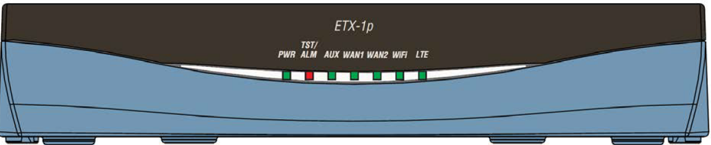

Figure 2: ETX-1P Front Panel LEDs

1. Connect a power supply to a test product ETX-1P and confirm a green LED PWR is on
2. Disconnect the power supply to the test product ETX-1P and confirm the LED PWR is off

LEDs may be tested with PCPE commands:

* Power on ETX-1P board - plug the power
* When the boot starts, hit any key to stop autoboot and get to the PCPE U-Boot prompt:

Need to see the command **Hit any key to stop autoboot: 0** and press “Enter"

PCPE>>

|  |  |  |
| --- | --- | --- |
| **Test LED** | **Command** | **LED Status** |
| TST/ALM IS GREEN/OFF | **gpio toggle GPIO112**  **gpio toggle GPIO112** | GREEN  OFF |
| TST/ALM IS RED/OFF | **gpio toggle GPIO113**  **gpio toggle GPIO113** | RED  OFF |
| WAN 1 IS GREEN | **mii write 2 1 0x80ef**  **mii write 2 0 0x9696** | GREEN |
| WAN 1 IS OFF | **mii write 2 1 0x80ee**  **mii write 2 0 0x9696** | OFF |
| WAN 2 IS GREEN | **mii write 2 1 0x80fe**  **mii write 2 0 0x9696** | GREEN |
| WAN 2 IS OFF | **mii write 2 1 0x80ee**  **mii write 2 0 0x9696** | OFF |
| WIFI IS GREEN (By order option) | **mii write 2 1 0x80fe**  **mii write 2 0 0x9676** | GREEN |
| Wifi is off (By order option) | **mii write 2 1 0x80ee**  **mii write 2 0 0x9676** | OFF |

Table 1: LED 'PWE,WAN 1,2 ,TET/ALM,WIFI' commands

* AUX and LTE LED testing is done through Linus:
* The LEDs may be tested with LINUX commands:
* Go into ETX-1P Linux shell the following:

user>***su***

password>***1234***

ETX-1p# ***logon debug***

Key code: 8388569129 ( Example)

Challenge code: (10 figure numbers)

Open Decryptor

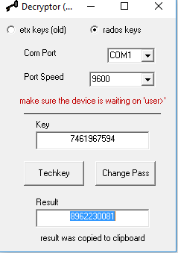

* Enter the code (Challenge code: in the field key)
* Push on (change pass), you will get a number (Result)
* Insert the number to UUT

password>**********

ETX-1p# ***debug shell***

[root@localhost /]#

see the command:

|  |  |  |
| --- | --- | --- |
| **Test LED** | **Command** | **LED Status** |
| AUX is green | **cd /sys/class/gpio/**  **echo 442 > export**  **echo out > gpio442/direction**  **echo 1 > gpio442/value** | GREEN |
| AUX is off | **echo 0 > gpio442/value** | OFF |
| AUX is RED | **cd /sys/class/gpio/**  **echo 443 > export**  **echo out > gpio443/direction**  **echo 1 > gpio443/value** | RED |
| AUX is off | **echo 0 > gpio443/value** | OFF |
| LTE is GREEN | **cd /sys/class/gpio/**  **echo 441 > export**  **echo out > gpio441/direction**  **echo 1 > gpio441/value** | GREEN |
| LTE is off | **echo 0 > gpio441/value** | OFF |

Table 2: LED AUX,LTE commands

### Back Panel LEDs tests

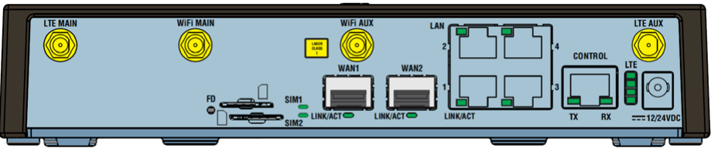

Figure 3: ETX-Back Panel LEDs

* Power on ETX-1P board - plug the power
* When the boot starts, hit any key to stop autoboot and get to the PCPE U-Boot prompt:

Need to see the command **Hit any key to stop autoboot: 0** and press “Enter"

PCPE>>

* LEDs may be tested with PCPE commands:

|  |  |  |
| --- | --- | --- |
| **Test LED** | **Command** | **LED Status** |
| SIM 1 is on | **mii write 1 1 0x90fe**  **mii write 1 0 0x9656** | GREEN |
| SIM 1 is off | **mii write 1 1 0x90ee**  **mii write 1 0 0x9656** | off |
| SIM 2 IS ON | **mii write 1 1 0x90fe**  **mii write 1 0 0x9636** | GREEN |
| Sim2 is off | **mii write 1 1 0x90ee**  **mii write 1 0 0x9636** | off |
| Wan 1 is on | **mii write 2 1 0x80ef**  **mii write 2 0 0x96B6** | GREEN |
| Wan 1 is off | **mii write 2 1 0x80ee**  **mii write 2 0 0x96B6** | off |
| Wan 2 is on | **mii write 2 1 0x80ef**  **mii write 2 0 0x9676** | GREEN |
| Wan 2 is off | **mii write 2 1 0x80ee**  **mii write 2 0 0x9676** | off |
| Lan 1 is on | **mii write 1 1 0x80ef**  **mii write 1 0 0x9636** | GREEN |
| Lan 1 is off | **mii write 1 1 0x80ee**  **mii write 1 0 0x9636** | off |
| Lan 2 is on | **mii write 1 1 0x80ef**  **mii write 1 0** 0x9656 | GREEN |
| Lan 2 is off | **mii write 1 1 0x80ee**  **mii write 1 0** 0x9656 | off |
| Lan 3 is on | **mii write 1 1 0x80ef**  **mii write 1 0** 0x9676 | GREEN |
| Lan 3 is off | **mii write 1 1 0x80ee**  **mii write 1 0** 0x9676 | off |
| Lan 4 is on | **mii write 1 1 0x80ef**  **mii write 1 0** 0x9696 | GREEN |
| Lan 4 is off | **mii write 1 1 0x80ee**  **mii write 1 0** 0x9696 | off |
| Ser1 TX is on | **mii write 1 1 0x90ef**  **mii write 1 0** 0x9636 | GREEN |
| Ser1 TX is off | **mii write 1 1 0x90ee**  **mii write 1 0** 0x9636 | off |
| Ser1 RX is on | **mii write 1 1 0x90ef**  **mii write 1 0** 0x9676 | GREEN |
| Ser1 RX is oFF | **mii write 1 1 0x90ee**  **mii write 1 0** 0x9676 | off |

Table 2: LED SIM 1,2,WAN 1,2,LAN1-4,SER commands

### Back Panel LED LTE test

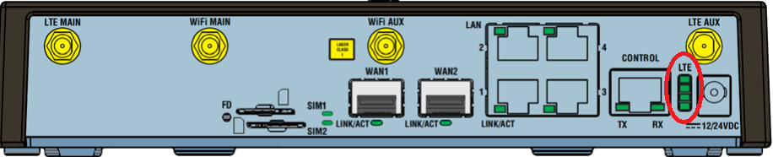

Figure 4: ETX-Back Panel LED LTE

* The LEDs may be tested with LINUX commands:
* Go into ETX-1P Linux shell the following:

user>***su***

password>***1234***

ETX-1p# ***logon debug***

Key code: 8388569129 (Example)

Challenge code: (10 figure numbers)

Open Decryptor



* Enter the code (Challenge code: in the field key)
* Push on (change pass), you will get a number (Result)
* Insert the number to UUT

password>**********

ETX-1p# ***debug shell***

[root@localhost /]# ***stty icrnl***

[root@localhost /]# ***cat > lte_ledtest.sh***

Open file download with notepad



***ctrl+D***

[root@localhost /]# ***cat > lte_ledbar_test.sh***

Open file download with notepad



***ctrl+D***

[root@localhost /]# ***chmod 777 lte_ledtest.sh***

[root@localhost /]# ***chmod 777 lte_ledbar_test.sh***

[root@localhost /]# ***./lte_ledbar_test.sh***

* Verify that you see that all 4 LEDs are lit in green
* Verify that all 4 LEDs are off

# Environmental Stress Screening (ESS)

1. As specified in the GFTI.

# Automated Final Tests

The following instructions reflect:

|  |  |
| --- | --- |
|  | **Last Updated** |
| Final Test Instructions | 14.01.2024 |
| Automatic Tester | 14.01.2024 |

## Setup

1. Connect the Tester’s cables to the following UUT’s ports: PWR, CONSOLE, SFP, 5 x UTP and S1.

2. According to order option insert two SIM cards.

3. According to order option connect Cellular, GPS and Wi-Fi antennas.

4. Scan the DUT’s ID barcode to configure the Tester accordingly.

## Running the Test

1. Press the “RUN” button to start running the test and follow the Instructions on the screen. If the test fails, the display will show a red Fail message and the test will be stopped, and you may resume testing from this point.

2. Verify that the test passed.

# Manual Final Tests

## General Function Tests

N/A

## Identification Test

1. Type as follows:

user>***su***

Password:***1234***

1. Verify the ID of Chassis and UUT’s are according to ECO and EEPROM following commands:

***config system***

config>system# ***show device-information***

|  |  |
| --- | --- |
| **ID** |  |
| Description | Sw: Verify the Version according to the latest ECO by order option  Hw: verify the HW version according to the latest ECO  Note: for Safaricom HW **still doesn’t supported, all options are 1.0** |
| MAC Address | Verify range:  **18:06:F5:**00:00:00 **- 18:06:F5:**FF:FF:FF  or  **00:20:D2:** 00: 00: 00 - **00:20:D2:** FF: FF: FF |
| Name | ETX-1p |

ETX-1p>config>system# **show summary-inventory**

|  |  |
| --- | --- |
| FW Ver | according to Option (ORDER) |

*Example: for* Safaricom Bold in yellow

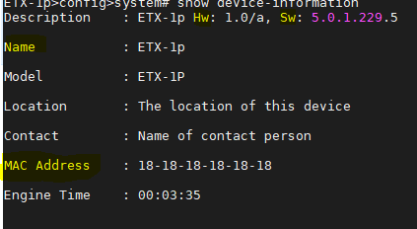



For general Bold in yellow

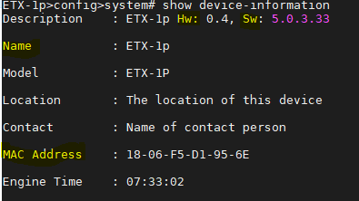



1. Connect Ethernet Generator to all WAN and LAN port and verify the ports SFP, RJ45 (According to by order option)

***exit all***

***configure port ethernet wan1***

config>port>eth(wan1)# ***no shutdown***

config>port>eth(wan1)# ***show status***

Note: Please execute the same commands to the following ports wan 2 and lan 1- 4

|  |  |  |
| --- | --- | --- |
| WAN 1 – 2  FOR general ONLY | Connector Type | SFP In or RJ45 |
| Administrative Status | up |
| Operational Status | up |
| SFP | Manufacturer Part Number | SFP-9G |
| Lan 1-4 | Connector Type | RJ45 |
| Administrative Status | up |
| Operational Status | up |
| WAN 1 for only Safaricom | Connector Type | SFP Out **still doesn’t support all options** |

* Power off and on ETX-1P board - plug the power
* When the boot starts, hit any key to stop autoboot and get to the PCPE U-Boot prompt:

Need to see the command **Hit any key to stop autoboot: 0** and press “Enter"

PCPE>>

* Verify the UBOOT (According to the latest ECO by order option)

U-Boot 2017.03.VER1.0.2-armada-17.10.2 (Nov 22 2021)

* Verify the DRAM: 1 GiB (According to order option)

*Example:U-BOOT,DRAM*

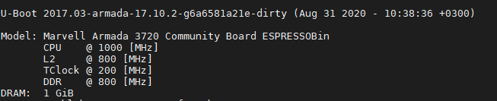

PCPE>> ***printenv NFS_VARIANT***

* Verify NFS_VARIANT=general (According to the latest ECO by order option)

## Test FD Button check

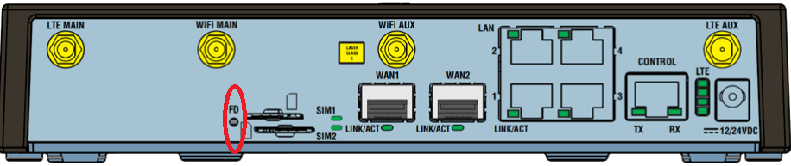

Figure 5: UUT for FD Test

* The test for reset for PCB 0.2
* Click on the pushbutton as shown in Figure 5
* Verify the device is rebooting and the Boot is processing
* The test for factory-default-config

Use following command:

user>su

password>1234

ETX-1p#

* Press the button for 10 seconds as shown in Figure 5
* Verify that the device is booting. Verify the message factory-default-config

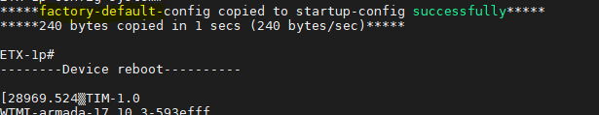

Note:

1. The FD button not working because a SW bug. As workaround: disconnect power and plug back in **approved only for SAFARICOM, MKT options ETX-1P_SFC/xxx**

## Cellular Modem Test (according to option)

* **Test for Safaricom**

1. Connect cellular Antenna to LTE MAIN.
2. Test Cellular SIM1,SIM2, the commands:

user>***su***

Password:***1234***

***configure port cellular lte***

config>port>cellular(lte)# ***no shutdown***

1. check the parameters the modem IMEI

config>port>cellular(lte)# ***show status***

*Example: IMEI*

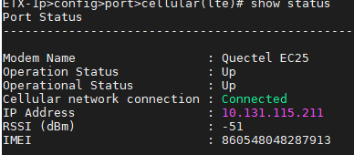

config>port>cellular(lte)# ***exit all***

* In **Safaricom** product the Cellular is tested with LINUX commands (use a special paragraphs for the **General** product):

ETX-1p# ***logon debug***

Key code: 8388569129 ( Example)

Challenge code: (10 figure numbers)

Open Decryptor



* Enter the code (Challenge code: in the field key)
* Push on Change Pass, you will get a number (Result)
* Insert the number to UUT

password>**********

ETX-1p# ***debug shell***

[root@localhost /]#

***echo "out" > /sys/class/gpio/gpio487/direction***

***echo "out" > /sys/class/gpio/gpio500/direction***

wait 5 seconds

***echo "1" > /sys/class/gpio/gpio500/value***

wait 10 seconds

Switch to sim1:

***echo "0" > /sys/class/gpio/gpio500/value***

***echo "1" > /sys/class/gpio/gpio487/value***

***echo "1" > /sys/class/gpio/gpio500/value***

wait 10 seconds

***/usr/sbin/quectel-CM -s internetg &***

* Execute the command again
* check the parameters SIM 1 *and* modem 1 only firmware version

|  |  |
| --- | --- |
| **requestGetSIMStatus SIMStatus:** | **SIM_READY** |
| **requestQueryDataCall IPv4ConnectionStatus:** | **CONNECTED** |
| **requestRegistrationState2 MCC: 425, MNC: 2, PS: Attached, DataCap:** | **LTE** |
| **requestBaseBandVersion** | Version: **according to the table below**  Check firmware version. |

**exit**

***configure port cellular lte***

config>port>cellular(lte)# ***show status***

|  |  |
| --- | --- |
| **RSSI (dBm)** | **-51 : -75** |

* Check cellular modem firmware version (according to the option)

Version: *according to the table below*

Check firmware version.

|  |  |
| --- | --- |
| **Model** | **Latest FW** |
| EC25-AUF (L3) | EC25AUFAR06A01M4G |
| UC20G (HSP) | UC20GQDR03A17E1G |
| EC-25EFA (L1) | EC25EFAR06A03M4G |
| EC-25AFA (L2) | EC25AFAR05A04M4G |
| EC25AFFD (L4) | EC25AFFDR07A09M4G |
| EC-25AFA (L2) | EC25AFAR05A04M4G |
| EM9191 | Revision: SWIX55C_03.09.11.00 7bf975jenkins 2022/06/10 20:36:01 |
| L-450A | Firmware : 0.3.4.1/ML620EUV12_RELEASE_20220709 |

*Example: SIM 1 and* modem firmware version

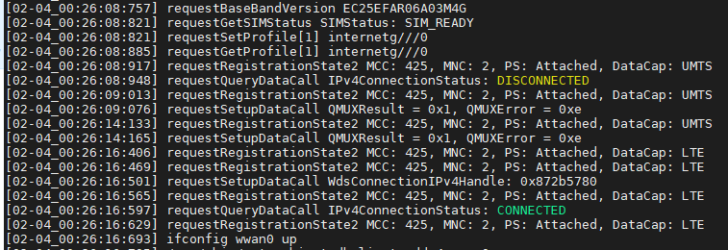

**ping 8.8.8.8 -c 5**

*Example:PING*

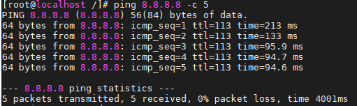

* Check the no packet loss

Switch to sim2:

***echo "0" > /sys/class/gpio/gpio500/value***

***echo "0" > /sys/class/gpio/gpio487/value***

***echo "1" > /sys/class/gpio/gpio500/value***

wait 10 seconds

***/usr/sbin/quectel-CM -s internetg &***

* Execute the command again
* check the parameters SIM 1

|  |  |
| --- | --- |
| **requestGetSIMStatus SIMStatus:** | **SIM_READY** |
| **requestQueryDataCall IPv4ConnectionStatus:** | **CONNECTED** |
| **requestRegistrationState2 MCC: 425, MNC: 2, PS: Attached, DataCap:** | **LTE** |

*Example: SIM 2*



**ping 8.8.8.8 -c 5**

*Example: PING*



* Check the no packet loss

***echo "0" > /sys/class/gpio/gpio500/value***

* **Test for General**

user>su

Password:1234

configure

        port

            cellular lte

sim 1

                apn-name "statreal"

exit

mode sim 1

                no shutdown

            exit

        exit

        router 1

            interface 1

                bind cellular lte

                dhcp

                dhcp-client

                    client-id mac

                exit

                no shutdown

            exit all

* check the parameters the modem sim 1

**configure port cellular lte**

config>port>cellular(lte)# **show status**

|  |  |
| --- | --- |
| **Cellular network connection** | **Connected** |
| **IMEI** | **866758044466866 (Example)** |
| **RSSI (dBm)** | **-51 : -75** |
| Administrative Status | Up |
| Operational Status | Up |
| Mode | SIM 1 |
| SIM Status | ready |
| Firmware | Check firmware version |

**Example:** firmware version

|  |  |
| --- | --- |
| **Model** | **Latest FW** |
| EC25-AUF (L3) | EC25AUFAR06A01M4G |
| UC20G (HSP) | UC20GQDR03A17E1G |
| EC-25EFA (L1) | EC25EFAR06A03M4G |
| EC-25AFA (L2) | EC25AFAR05A04M4G |
| EC25AFFD (L4) | EC25AFFDR07A09M4G |
| EC-25AFA (L2) | EC25AFAR05A04M4G |
| EM9191 | Revision: SWIX55C_03.09.11.00 7bf975jenkins 2022/06/10 20:36:01 |
| L-450A | Firmware : 0.3.4.1/ML620EUV12_RELEASE_20220709 |

**Example:**

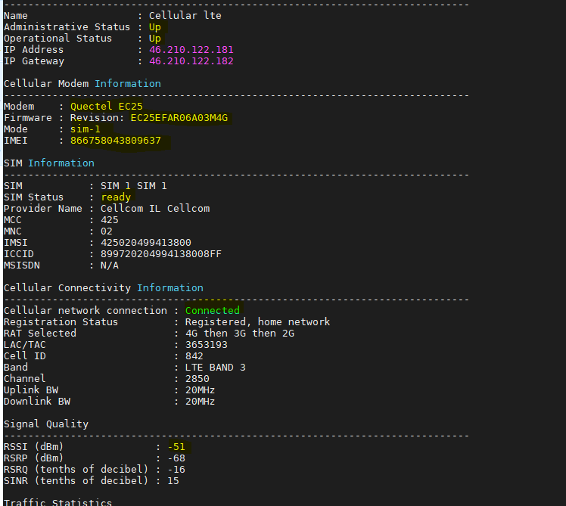

**Ping 8.8.8.8**

**Example ping :**

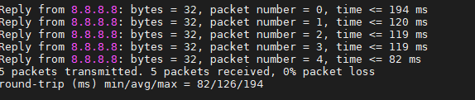

* Switch to sim2:

**exit all**

**configure port cellular lte**

config>port>cellular(lte)# **shutdown**

**sim 2**

                apn-name "statreal"

**exit**

**mode sim 2**

**no shutdown**

**exit all**

**configure port cellular lte**

config>port>cellular(lte)# **no shutdown**

* check the parameters the modem sim 2

config>port>cellular(lte)# **show status**

|  |  |
| --- | --- |
| **Cellular network connection** | **Connected** |
| **RSSI (dBm)** | **-51 : -75** |
| Administrative Status | Up |
| Operational Status | Up |
| Mode | SIM 2 |
| SIM Status | ready |

**Example:**

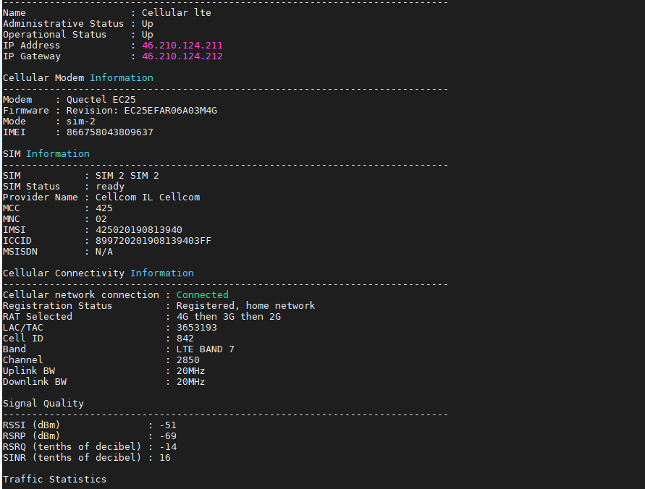

**Ping 8.8.8.8**

**Example ping :**



* Check the no packet loss

### dual modem

7.5 Cellular Modem test (according to option)

1. Connect cellular Antenna to LTE MAIN.

2. Test Cellular SIM1,SIM2, the commands:

user>su

Password:1234

configure

port

cellular lte-1

sim 1

apn-name "statreal"

exit

no shutdown

exit

cellular lte-2

sim 1

apn-name "statreal"

exit

no shutdown

exit

exit

router 1

interface 1

bind cellular lte-1

dhcp

dhcp-client

client-id mac

exit

no shutdown

exit

interface 2

bind cellular lte-2

dhcp

dhcp-client

client-id mac

exit

no shutdown

exit

exit all

• check the parameters the modem sim 1

configure port cellular lte-1

config>port>cellular(lte)# show status

Cellular network connection Connected

IMEI 866758044466866 (Example)

RSSI (dBm) -51 : -75

Administrative Status Up

Operational Status Up

Mode SIM 1

SIM Status ready

Firmware Check firmware version

1. Firmware: Check firmware version according to the table below:

|  |  |
| --- | --- |
| **Model** | **Latest FW** |
| EC25-AUF (L3) | EC25AUFAR06A01M4G |
| UC20G (HSP) | UC20GQDR03A17E1G |
| EC-25EFA (L1) | EC25EFAR06A03M4G |
| EC-25AFA (L2) | EC25AFAR05A04M4G |
| L-450A | Firmware : 0.3.4.1/ML620EUV12_RELEASE_20220709 |
| EM9191 | Revision: SWIX55C_03.09.11.00 7bf975jenkins 2022/06/10 20:36:01 |

**

Exit all

configure port cellular lte-2

config>port>cellular(lte)# show status

Cellular network connection Connected

IMEI 866758044466866 (Example)

RSSI (dBm) -51 : -75

Administrative Status Up

Operational Status Up

Mode SIM 1

SIM Status ready

Firmware Check firmware version

Firmware Check firmware version according to the table below:

|  |  |
| --- | --- |
| **Model** | **Latest FW** |
| EC25-AUF (L3) | EC25AUFAR06A01M4G |
| UC20G (HSP) | UC20GQDR03A17E1G |
| EC-25EFA (L1) | EC25EFAR06A03M4G |
| EC-25AFA (L2) | EC25AFAR05A04M4G |
| EM9191 | Revision: SWIX55C_03.09.11.00 7bf975jenkins 2022/06/10 20:36:01 |
| L-450A | Firmware : 0.3.4.1/ML620EUV12_RELEASE_20220709 |

**

exit all

logon debug

copy the key code to Decryptor

press on “change pass”

copy the result and past them to password line in procomm

debug shell

check 8.8.8.8 ping statistics for 0% packet loss

Example:

[root@localhost /]# ping 8.8.8.8 -I wwan0 -c 5

PING 8.8.8.8 (8.8.8.8) from 46.210.111.173 wwan0: 56(84) bytes of data.

64 bytes from 8.8.8.8: icmp_seq=1 ttl=117 time=153 ms

64 bytes from 8.8.8.8: icmp_seq=2 ttl=117 time=37.3 ms

64 bytes from 8.8.8.8: icmp_seq=3 ttl=117 time=37.4 ms

64 bytes from 8.8.8.8: icmp_seq=4 ttl=117 time=44.7 ms

64 bytes from 8.8.8.8: icmp_seq=4 ttl=117 time=44.7 ms

check 8.8.8.8 ping statistics for 0% packet loss

--- 8.8.8.8 ping statistics ---

5 packets transmitted, 5 received, 0% packet loss, time 3001ms

rtt min/avg/max/mdev = 37.350/68.154/153.077/49.123 ms

[root@localhost /]# ping 8.8.8.8 -I wwan1 -c 5

PING 8.8.8.8 (8.8.8.8) from 46.210.126.145 wwan1: 56(84) bytes of data.

64 bytes from 8.8.8.8: icmp_seq=1 ttl=117 time=48.3 ms

64 bytes from 8.8.8.8: icmp_seq=2 ttl=117 time=32.3 ms

64 bytes from 8.8.8.8: icmp_seq=3 ttl=117 time=31.5 ms

64 bytes from 8.8.8.8: icmp_seq=4 ttl=117 time=37.8 ms

64 bytes from 8.8.8.8: icmp_seq=4 ttl=117 time=37.8 ms

check 8.8.8.8 ping statistics for 0% packet loss

### dual modem L4

7.5 Cellular Modem test (according to option)

1. Connect cellular Antenna to LTE MAIN.

2. Test Cellular SIM1,SIM2, the commands:

user>su

Password:1234

configure

port

cellular lte-1

sim 1

apn-name "statreal"

exit

no shutdown

exit

cellular lte-2

sim 1

apn-name "statreal"

                pdp-type relayed-ppp

exit

no shutdown

exit

exit

router 1

interface 1

bind cellular lte-1

dhcp

dhcp-client

client-id mac

exit

no shutdown

exit

interface 2

bind cellular lte-2

dhcp

dhcp-client

client-id mac

exit

no shutdown

exit

exit all

• check the parameters the modem sim 1

configure port cellular lte-1

config>port>cellular(lte)# show status

Cellular network connection Connected

IMEI 866758044466866 (Example)

RSSI (dBm) -51 : -75

Administrative Status Up

Operational Status Up

Mode SIM 1

SIM Status ready

Firmware Check firmware version

1. Firmware: Check firmware version according to the table below:

|  |  |
| --- | --- |
| **Model** | **Latest FW** |
| EC25-AUF (L3) | EC25AUFAR06A01M4G |
| UC20G (HSP) | UC20GQDR03A17E1G |
| EC-25EFA (L1) | EC25EFAR06A03M4G |
| EC-25AFA (L2) | EC25AFAR05A04M4G |
| EM9191 | Revision: SWIX55C_03.09.11.00 7bf975jenkins 2022/06/10 20:36:01 |
| L-450A | Firmware : 0.3.4.1/ML620EUV12_RELEASE_20220709 |

**

Exit all

configure port cellular lte-2

config>port>cellular(lte)# show status

Cellular network connection Connected

IMEI 866758044466866 (Example)

RSSI (dBm) -51 : -75

Administrative Status Up

Operational Status Up

Mode SIM 1

SIM Status ready

Firmware Check firmware version

Firmware Check firmware version according to the table below:

|  |  |
| --- | --- |
| **Model** | **Latest FW** |
| EC25-AUF (L3) | EC25AUFAR06A01M4G |
| UC20G (HSP) | UC20GQDR03A17E1G |
| EC-25EFA (L1) | EC25EFAR06A03M4G |
| EC-25AFA (L2) | EC25AFAR05A04M4G |
| EM9191 | Revision: SWIX55C_03.09.11.00 7bf975jenkins 2022/06/10 20:36:01 |
| L-450A | Firmware : 0.3.4.1/ML620EUV12_RELEASE_20220709 |

**

exit all

logon debug

copy the key code to Decryptor

press on “change pass”

copy the result and past them to password line in procomm

debug shell

check 8.8.8.8 ping statistics for 0% packet loss

Example:

[root@localhost /]# ping 8.8.8.8 -I wwan0 -c 5

PING 8.8.8.8 (8.8.8.8) from 46.210.111.173 wwan0: 56(84) bytes of data.

64 bytes from 8.8.8.8: icmp_seq=1 ttl=117 time=153 ms

64 bytes from 8.8.8.8: icmp_seq=2 ttl=117 time=37.3 ms

64 bytes from 8.8.8.8: icmp_seq=3 ttl=117 time=37.4 ms

64 bytes from 8.8.8.8: icmp_seq=4 ttl=117 time=44.7 ms

64 bytes from 8.8.8.8: icmp_seq=4 ttl=117 time=44.7 ms

check 8.8.8.8 ping statistics for 0% packet loss

--- 8.8.8.8 ping statistics ---

5 packets transmitted, 5 received, 0% packet loss, time 3001ms

rtt min/avg/max/mdev = 37.350/68.154/153.077/49.123 ms

[root@localhost /]# ping 8.8.8.8 -I wwan1 -c 5

PING 8.8.8.8 (8.8.8.8) from 46.210.126.145 wwan1: 56(84) bytes of data.

64 bytes from 8.8.8.8: icmp_seq=1 ttl=117 time=48.3 ms

64 bytes from 8.8.8.8: icmp_seq=2 ttl=117 time=32.3 ms

64 bytes from 8.8.8.8: icmp_seq=3 ttl=117 time=31.5 ms

64 bytes from 8.8.8.8: icmp_seq=4 ttl=117 time=37.8 ms

64 bytes from 8.8.8.8: icmp_seq=4 ttl=117 time=37.8 ms

check 8.8.8.8 ping statistics for 0% packet loss

## GPS Test (according to option)

the commands:

**configure system clock gnss 1**

config>system>clock>gnss(1)# ***secondary-system glonass galileo beidou***

*config>system>clock>gnss(1)#* ***no shutdown***

*config>system>clock>gnss(1)#* ***show status***

* check the parameters

|  |  |
| --- | --- |
| Administrative Status : Up | up |
| Operational Status | up |
| Tracking Status | GNSS Locked |

## Wi-Fi Test (according to option)

|  |
| --- |
| Note:  Place the computer with WiFi adaptor in a distance from UUT |

## Wi-Fi test (according to option)

|  |
| --- |
| Note:  Place the computer with WiFi adaptor in a distance from UUT |

1. Set the bellow setup:

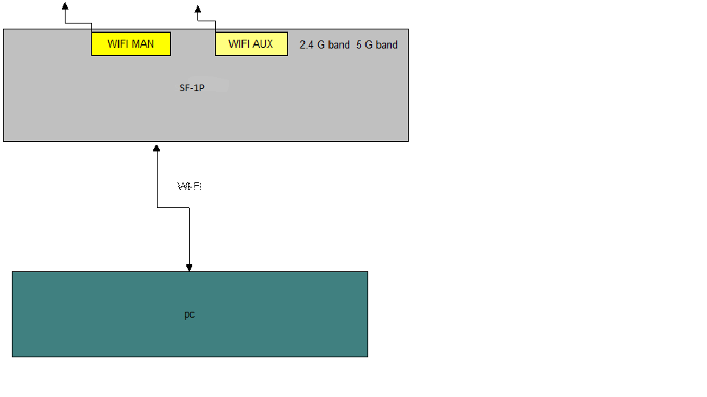

Figure 6 : SF-1P Test WI-FI

1. Connect antenna for testing WIFI MAIN and WIFI AUX
2. Configure WiFi module to predefined channel (free) in 2.4G band and transmit over WIFI MAIN and WIFI AUX antenna with optimal power
3. Perform the bellow commands:

user>su

password>1234

Configure system dhcp-server 1

pool "1"

network 50.50.50.0/24

address-range 50.50.50.50 50.50.50.52

exit

no shutdown

exit

exit

port

wlan 1

radio-mode 802.11g

channel 4

access-point 1

ssid "2G"

password "1234" hash

max-clients 8

no shutdown

exit all

configure

router 1

interface 1

address 50.50.50.1/24

bind wlan 1 access-point 1

dhcp-client

client-id mac

exit

no shutdown

exit all

1. Check the following parameters:
2. Click an icon on your computer in the red bar on the image

Example:



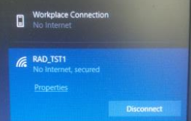

1. Connect with the following

SSID: 2G

1. Click on properties and verify the details:

|  |  |
| --- | --- |
| SSID | 2G |
| PROTOCOL | 802.11g (only 2.4G) |
| IPv4 address | 50.50.50.52 Example |

Example:

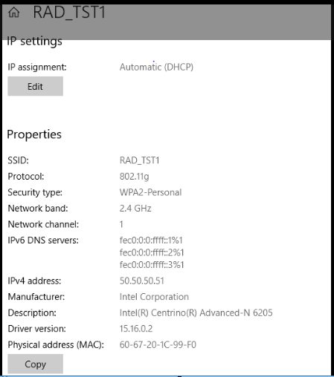

1. Test communication from SF-1P to PC over the established WLAN:

Send ping 50.50.50.52 (Example) and verify reply with no loss

1. Open RUN command screen on PC

Check the signal percentage with the bellow commands:

Example:

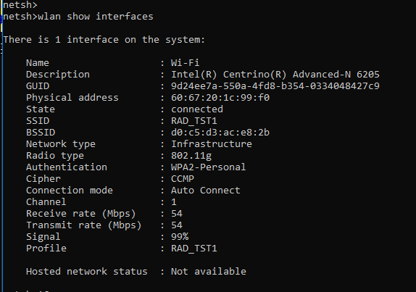

## Data Test



Figure 6: ETX-1P Test DATA running

**Note:** port WAN 1and WAN 2 connect with SFP-9G for according to option order only SFP

1. Type as follows:

* The Cellular is tested with LINUX commands:

ETX-1p# ***logon debug***

Key code: 8388569129 ( Example)

Challenge code: (10 figure numbers)

Open Decryptor



* Enter the code (Challenge code: in the field key)
* Push on Change Pass, you will get a number (Result)
* Insert the number to UUT

password>**********

ETX-1p# ***debug shell***

[root@localhost /]#

brctl addbr br0;

brctl addif br0 wan1;

brctl addif br0 wan2;

ifconfig wan1 up;

ifconfig wan2 up;

ifconfig br0 up;

brctl addbr br1;

brctl addif br1 lan0;

brctl addif br1 lan1;

ifconfig lan0 up;

ifconfig lan1 up;

ifconfig br1 up;

brctl addbr br2;

brctl addif br2 lan3;

brctl addif br2 lan2;

ifconfig lan2 up;

ifconfig lan3 up;

ifconfig br2 up;

1. Configure the ETX-204A Generator 1 and 2 according to ‎Appendix B
2. Verify DATA running without errors for 1 minutes in the ETX-204 generator
3. Confirm each generator has a Link-State is Up, “PRBS_OK” with running numbers and ERR-CNT = 0, PRBS_ERR=0, FRAME_ERR=0, SEQ_ERR=0.  
    follows:

Example:

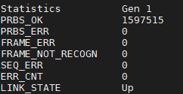

## Test SSH connection ETH port 4 or 6 test (according to option)

At the end of all the tests we find the device with the default IP 169.254.1.1/16

Connect terminal to Serial Port 2 (upper connector) and relocate jumper J21 as shown in figure below:



Figure 8 : SF-1P Test SSH

* Open SSH session with SF-1P device Ethernet Port4 or port 6 for Order option.
* Open Putty for ssh session and connect to SF-1P device (see below). Perform authorization into opened ssh session window:

* Click the open button
* Type as follows:

user>su

Password:1234

SF-1p#

Note:

1. in SAFARICOM option remove the J21 JUMPER after the test!

**MKT options ETX-1P_SFC/xxx**

# Preparations for Shipment

1. As specified in the GFTI.
2. SFP ports covers.
3. Verify correct voltage indications
4. Make sure the screw-nut of the coax connectors (ANT & MI/DV) is closed.
5. Confirm the existence of the bar code label.

# Factory Setting

1. As specified in the GFTI.
2. Return to factory setting:

***admin factory-default***

Current configuration will be erased and device will reboot with factory default configuration. Are you sure? [yes/no]_yes

# Safety Test

As specified in the GFTI.

1. EEPROM Parameters

EEPROM parameters (By order option)

Example of EEPROM identifying string

MODEM_1_MANUFACTURER=QUECTEL,MODEM_2_MANUFACTURER=QUECTEL,MODEM_1_TYPE=EC25­E,MODEM_2_TYPE=EC25­E,MAC_ADDRESS=00:a7:b1:46:4e:a3,MAIN_CARD_HW_VERSION=0.0,SUB_CARD_1_HW_VERSION=0.1,CSL=A,PART_NUMBER=ETX­1P/ACEX/1SFP1UTP/4UTP,PCB_MAIN_ID=SF­1V/MAIN/0.1I,PCB_SUB_CARD_1_ID=SF­1V/PS/0.1I,PS=WDC­12V,SD_SLOT=YES,SERIAL_1=RS232,SERIAL_2=RS232,SERIAL_1_CTS_DTR=YES,SERIAL_2_CTS_DTR=YES,RS485_1=,RS485_2=,DRY_CONTACT=YES,NNI_PORT_4=COPPER,NNI_PORT_5=COPPER,PORT_2_3=YES,LIST_REF=0.0,END=

|  |  |  |
| --- | --- | --- |
| Name | Possible Values | Comments |
| MODEM_1_MANUFACTURER | QUECTEL | Null (no value) if modem is not present |
| MODEM_2_MANUFACTURER | QUECTEL  AZUREWAVE  RAK | Null (no value) if modem is not present  WiFi, WF ordering option  LoRa ordering option |
| MODEM_1_TYPE | UC20  EC25-E  EC25-A  EC25-AU  EC25-AFFD | Null (no value) if modem is not present  QUECTEL, HSP ordering option  QUECTEL, L1 ordering option  QUECTEL, L2 ordering option  QUECTEL, L3 ordering option  QUECTEL, L4 ordering option |
| MODEM_2_TYPE | UC20  EC25-E  EC25-A  EC25-AU  EC25-AFFD  AW-CM276MA  EU433  EU868  US915  US915  AS923  EU868 | Null (no value) if modem is not present  QUECTEL, HSP ordering option  QUECTEL, L1 ordering option  QUECTEL, L2 ordering option  QUECTEL, L3 ordering option  QUECTEL, L4 ordering option  AZUREWAVE, WF ordering option  RAK, LoRa ordering option LR1  RAK, LoRa ordering option LR2  RAK, LoRa ordering option LR3  RAK, LoRa ordering option LR4  RAK, LoRa ordering option LR6  RAK, LoRa ordering option LR7 |
| MAC_ADDRESS | AA:BB:CC:DD:EE:FF | 10 consecutive addresses, starting with the specified |
| MAIN_CARD_HW_VERSION |  | Filled by Badas |
| SUB_CARD_1_HW_VERSION |  | Null (no value) if there is no sub card |
| CSL |  | Filled by Badas |
| PART_NUMBER |  | Refer to [1P Ordering Options] for possible values |
| PCB_MAIN_ID |  | Filled by Badas |
| PCB_SUB_CARD_1_ID |  | Null (no value) if there is no sub card |
| PS | 12V  WDC-12V | 12V DC  Wide range 10V to 30V DC |
| SD_SLOT | YES | Null (no value) if SD card slot is not present |
| SERIAL_1 | RS232  RS485 | Null (no value) if serial is not present  Non isolated RS232  Non isolated RS485 |
| SERIAL_2 | RS232 | Null (no value) if serial is not present  Non isolated RS232 |
| SERIAL_1_CTS_DTR | YES | Null (no value) if serial is not present  CTS and DTR are supported |
| SERIAL_2_CTS_DTR | YES | Null (no value) if serial is not present  CTS and DTR are supported |
| RS485_1 | 2W | Null (no value) if RS485 is not supported  Half duplex RS485 |
| RS485_2 |  | Null (no value); RS485 is not supported on serial-2 |
| DRY_CONTACT_IN_OUT | 2_2  3_1 | Null (no value) if there are no dry contacts  2 in and 2 out dry contacts  3 in and 1 out dry contacts |
| NNI_WAN_1 | FIBER | Null (no value) if there is no interface  NNI port 1 is SFP |
| NNI_WAN_2 | COPPER  FIBER | Null (no value) if there is no interface  NNI port 2 is RJ-45  NNI port 2 is SFP |
| LAN_3_4 | YES | Null (no value) if ports are not present  MNI ports 3-4 are available |
| END |  | Null (no value), denoting end of string |

1. ETX-204 generator configuration
2. Configure the parameters as shown below in yellow

Main Menu

3. Generator >

>3 Press "Enter"

ETX-204A-AC

*Generator

1. Generator number > (All)

2. Generator mode (GE)

3. Packet type > (MAC)

8. Packet rate[1 - 1500000] ... (115000)

14. Save

>14 Press "Enter"

ETX-204A-AC

*Generator

1. Generator number > (All)

>1 Press "Enter"

ETX-204A-AC

Generator>Generator number (Generator 1)

1. Generator 1

2. Generator 2

3. Generator 3

4. Generator 4

5. All

>1

ETX-204A-AC

*Generator

1. Generator number > (Generator 1)

14. Save

>14 Press "Enter"

ETX-204A-AC

Generator

1. Generator number > (Generator 1)

11. Base SA/DA >

>11 Press "Enter"

ETX-204A-AC

Generator>Base SA/DA

1. Generator num > (Generator 1-2)

|  |  |  |
| --- | --- | --- |
| Generator | Base DA | Base SA |
| Generator1 (WAN1) | 00-00-00-00-00-05 | 00-00-00-00-00-01 |
| Generator2 (WAN2) | 00-00-00-00-00-01 | 00-00-00-00-00-05 |

>S

Please select item <1 to 13>

S-Save to FPGA

ETX-204A-AC

*Generator

9. Generator statistics []

>9 Press "Enter"

ETX-204A-AC

Generator>Generator statistics

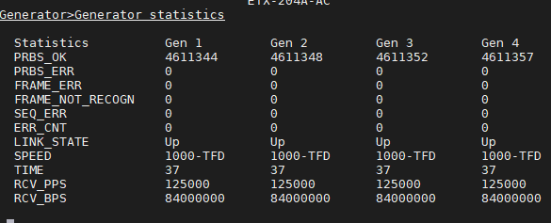

>

H-Stop; C-Clear all; F-Clear one; S-Save to FPGA

1. Configure the ETX-204A Generator 2 as follows:
2. Configure the parameters as shown on the page that appears in yellow
3. At the end of the process make sure all the parameters are correct

ETX-204A-AC

*Generator

1. Generator number > (All)

2. Generator mode (GE)

3. Packet type > (MAC)

8. Packet rate[1 - 1500000] ... (125000)

14. Save

>14 Press "Enter"

ETX-204A-AC

Generator

1. Generator number > (All)

>1 Press "Enter"

ETX-204A-AC

Generator>Generator number (All)

1. Generator 1

2. Generator 2

3. Generator 3

4. Generator 4

5. All

>1 Press "Enter"

ETX-204A-AC

Generator>Base SA/DA

1. Generator num > (Generator 1-4 )

|  |  |  |
| --- | --- | --- |
| Generator | Base DA | Base SA |
| Generator1 (LAN1) | 00-00-00-00-00-10 | 00-00-00-00-00-11 |
| Generator2 (LAN2) | 00-00-00-00-00-11 | 00-00-00-00-00-10 |
| Generator3 (LAN3) | 00-00-00-00-00-07 | 00-00-00-00-00-03 |
| Generator4 (LAN4) | 00-00-00-00-00-03 | 00-00-00-00-00-07 |

>S

Please select item <1 to 13>

S-Save to FPGA

ETX-204A-AC

*Generator

9. Generator statistics []

>9 Press "Enter"

ETX-204A-AC

Generator>Generator statistics



>

H-Stop; C-Clear all; F-Clear one; S-Save to FPGA